Example: LOAD Keyword
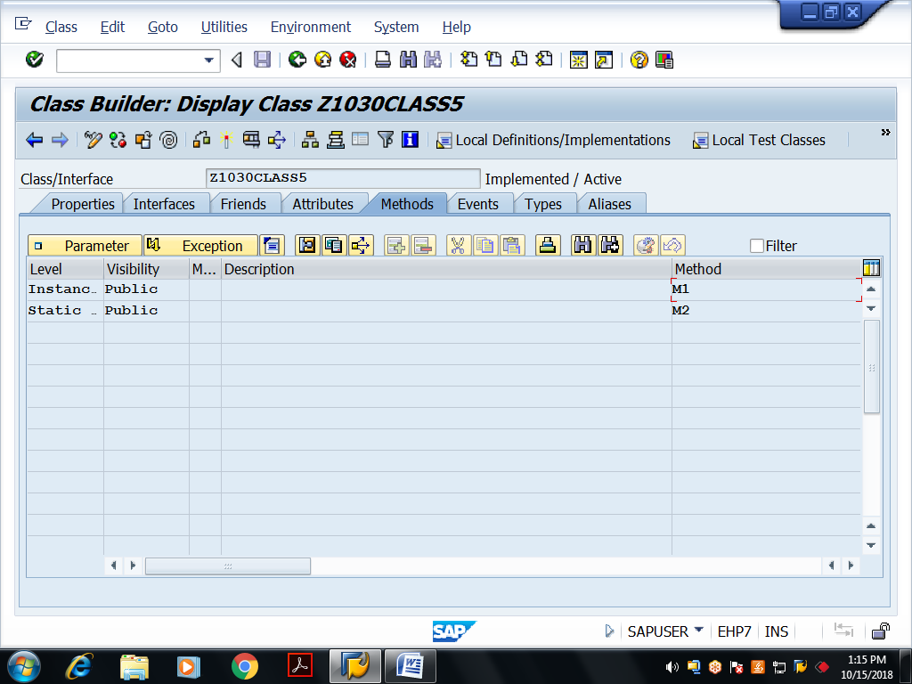
Save and activate
Method Implementations:
method M1.
write :/ 'Inside Instance public method m1...'.
endmethod.
method M2.
write :/ 'Inside Static public method m2...'.
endmethod.

Executable Program: To access above global class static components
REPORT Z1030OOPS11.
class z1030class5 DEFINITION load.
call method z1030class5=>m2.
Example: Instance Constructor with and without parameters
REPORT Z1030OOPS12.
class lcl_emp1 DEFINITION.
public SECTION.
methods : set,
display.
PROTECTED SECTION.
data : empno type i,
ename(20) type c.
endclass.
class lcl_emp1 IMPLEMENTATION.
method set.
empno = 5.
ename = 'Raju'.
endmethod.
method display.
write :/ empno,ename.
endmethod.
endclass.
class lcl_emp2 DEFINITION.
public SECTION.
methods : constructor,
display.
PROTECTED SECTION.
* methods : constructor. "syntax error
data : empno type i,
ename(20) type c.
endclass.
class lcl_emp2 IMPLEMENTATION.
method constructor.
empno = 5.
ename = 'Raju'.
endmethod.
method display.
write :/ empno,ename.
endmethod.
endclass.
class lcl_emp3 DEFINITION.
public SECTION.
methods : constructor IMPORTING i_empno type i
i_ename type c OPTIONAL,
display.
PROTECTED SECTION.
data : empno type i,
ename(20) type c.
endclass.
class lcl_emp3 IMPLEMENTATION.
method constructor.
empno = i_empno.
ename = i_ename.
endmethod.
method display.
write :/ empno,ename.
endmethod.
endclass.
START-OF-SELECTION.
write :/ 'Class -- LCL_EMP1...'.
data ob1 type ref to lcl_emp1.
create object ob1.
call method ob1->display.
uline.
write :/ 'Class -- LCL_EMP2...with Constructor'.
data ob2 type ref to lcl_emp2.
create object ob2.
*call method ob2->constructor. "syntax error
call method ob2->display.
call method ob2->display.
uline.
write :/ 'Class -- LCL_EMP3...with Constructor parameters..'.
write :/ 'Object ob3...'.
data ob3 type ref to lcl_emp3.
*create object ob3. "syntax error
PARAMETERS : p_empno type i,
p_ename(20) type c.
create object ob3
EXPORTING
i_empno = p_empno
i_ename = p_ename.
call method ob3->display.
uline.
write :/ 'Object ob4...'.
data ob4 type ref to lcl_emp3.
create object ob4
EXPORTING
i_empno = p_empno.
call method ob4->display.

